Step by step guide for the family

1. The family member given access logs on in the app.

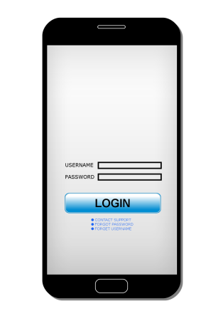

1. The main menu is displayed and the family members can choose the time table and can see who has been there. Comments will show messages shared with the family and what has been done. It is also possible to order food from the main menu from kolonial.no that delivers food home to the patient. The family can see what has been ordered and delivered.

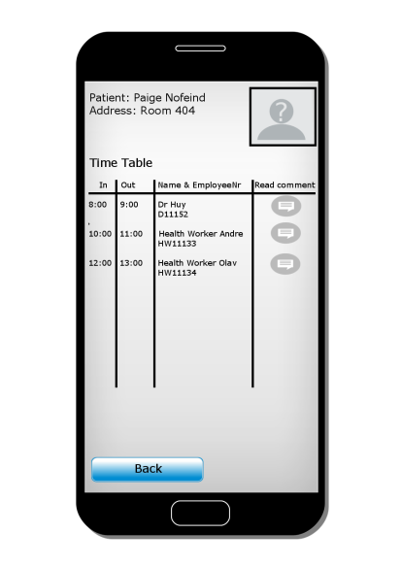

1. The family can also make comments and to send to:

* Healthcare workers
* Nurse
* Driver
* Senior center
* State

If the patient is on vacation it is easy to inform that relevant parties that they don’t need to come and if the assignments are not done it is easy to send a message to the state. Also the family can let the healthcare workers now if the patient needs to wear any special clothes or other needs.

